CDE & UNIX WORKSHEET

This worksheet is for the first two CS22210 practicals..

Part 1: how to
- Login to the Computer Science network.
- Use the Common Desktop Environment.
- Use some simple Unix commands. ( pwd, mkdir, ls, cd, more )
create a directory.
create a file using the editor gvim and save it into the new directory.
move and copy files using mv and cp
- Practise gvim
- Print files on a Dot Matrix printer or the Line Printer using lpr
- Find the online help. ( man etc.)
- Logout.

Note 1
There are many things that are easier to demonstrate than describe. If anything puzzles you ask for help.

Note 2
This is mainly a familiarisation session. If you have experience of computers and windows you will know yourself how to get started on a new system. Just be sure that you know how to find the online help, and try out gvim and some Unix commands.

1. Logging in

If you are sitting at a machine running Solaris you will be connected directly to the Computer Science network when you log in, but if you are using a machine running Windows you have to log in to Windows first and request a Computer Science connection, as follows:-

1a. Windows log in (Solaris users skip this subsection, go to 1b.)
Follow the instructions on the screen to log in to Windows.
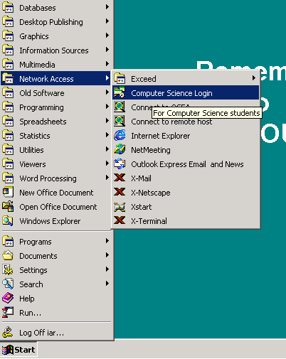At the left of the Task Bar is the Start button. Click on it.

This will give you a pop up menu.
Choose Network Access and Computer Science Login.

You should now have another log in screen inviting you to log in to Stonkin. From now on everything should be exactly the same as if you were sitting at a machine running Solaris, except that when you want to logout you must remember to logout twice, once from Stonkin and once from Windows

Note:-
The program that connects you to Stonkin, (called Exceed) provides a few extra facilities such as copying and pasting between CDE and the Windows clipboard. This might be useful later when writing documentation

End of subsection 1a.
***************************************************************************
1b. Logging in to Computer Science ( all do this)
Type your username. (In lower case. Unix is fussy about case)
Then press return or click on OK to let the computer know that you have finished. After a short pause the computer will prompt for your password. The characters you type as you enter your password will not be echoed to the screen. This is a security feature.
If the machine accepts you, you will be offered a choice of environments (in a blue window). Choose The Common Desktop Environment.

2. The Common Desktop Environment

Your screen will rearrange itself, and display three windows on a blue-grey background.
At the bottom is a pictorial menu called the Front Panel.

The icons on the Front Panel are, on the left:- StarOffice, The Netscape Web Browser, A Calendar, File Manager, A text Note Pad and E-Mail(Do not use this one). On the right are:- A printer manager(you won’t need this), Desktop Controls ( allows you to customise your windows), Performance Meter, Help Viewer and Trash Can. The Help Viewer and the File Manager are already open if this is the first time you have used CDE.
In the middle of the Front panel are four numbered buttons that allow you to switch between four different workspaces. There’s a lock for locking the screen (for short periods only please), a globe that spins when things are happening and the EXIT button.
The Help Viewer only holds topics to do with the Common Desktop Environment, it is no help with UNIX. However you might like to spend a few minutes looking at "Introducing the Desktop,” “Basic Desktop Skills”, “Working with Windows".

You can move windows about by dragging them, and change their size by dragging a side or a corner. Try moving things about.

The File Manager shows you the files in your filestore. There are two directories, but no files yet. The two directories are part of the set-up you need for e-mail and the Web, and were put there by the Support group.

Close the Help Viewer, but leave the File manager open for the moment. It will be useful to illustrate what is happening when you alter your filestore in the next section.

3. Some Simple Unix Commands.

Open a terminal window. To do this, click here for a pop-up menu.
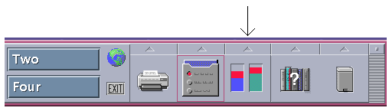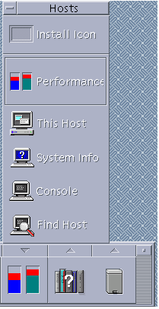

Then click on This Host. ->

When the Terminal window appears you can put away the pop up menu. (Click the triangle button again, it should be pointing down,
or double click on the little button at the top left corner of the menu).

You should now have a window with a Unix prompt in it, something like
stonkin:xyz99>
It should be the active window, and so have a pretty pink border, if not, click on it.
Try typing the Unix command pwd into your terminal window. The computer will reply with the path to the working directory, the directory you are in now. The path should end with your user-id, because you should be in your home directory. Compare this with the information at the top of your File Manager window.
Type ls in your terminal window. This will list the files and directories in your working directory, the same as in the File Manager window.

Create a directory.
In your terminal window type mkdir test
Now type ls to see if the new directory is there.
Look at the File Manager window; it should also show the new directory.

Now to move into the new directory, type the command cd test in the terminal window.
Notice your prompt has changed, to indicate where you are.

The change of directory only applies to the window you were in when you gave the command. The File Manager window is still looking at your home directory. Double click on the icon for the test directory to make the File Manager move down into it.

Create a file using gvim, and save it into the new directory.
You will need to know how to create a file into a particular directory when you have your first Java practical session. The easiest way is to BE IN the directory when you start gvim.

Try the Unix command ls to get a list of files.
You have no files in the test directory at present, so ls should give nothing.
Try the Unix command more testfile
This is asking to see the contents of testfile. This file does not exist yet, so you will get an error message. NOTE If Unix is able to carry out your commands successfully, it does it quietly; if it sends you messages it means something is wrong. Always ASK if you get a message you do not understand.

The recommended editor is called gvim. You cannot open it from the Front Panel, so you must get it through your terminal window using a Unix command.

The simplest way to start gvim is to give it a filename, as in:-
gvim testfile

You should get a new window with the full pathname to testfile in the title bar at the top and a lot of squiggles down the left hand side. Gvim labels empty lines with squiggles.
Now shuffle your windows around so that you can see the File Manager window and the Terminal window as well as the gvim window.
You will be seeing a great deal of gvim, but for now we just want to try it out.
Make sure the gvim window is active (has a pretty pink border) if not, click on it.
When gvim starts up it is in normal, or editing, mode. See what happens if you type something like
“Feed Me”
Nothing shows in the window, but the machine beeps at you!

Now change to insert mode by typing the i key. Nothing shows, except that the shape of the cursor changes, but now the screen will accept your typing. Try something like
"This is a test of gvim." (And/or anything else you like)
Save the file and quit gvim. To do this, either :-
1.Press the Esc key to get out of insert mode. Type :wq (colon wq)
or
2. Select Save-Exit from the File menu.

Check the File manager to see if the file is there.
Try the ls command in your Terminal window.
Try more testfile again. This time you should see the contents of the file.

Notice that testfile is in the directory called test. This is because you were in test when you started gvim.
When you reach this point in the worksheet please ask a demonstrator to check that testfile is inside the directory called test.

Moving Files
Suppose you did create testfile in the wrong place. You can move it from your home directory to the test directory where it should be using
mv testfile test provided you are in your home directory. If testfile is in some other funny place ask a demonstrator for help!

Copying Files
For the next section you need some fairly big chunks of text. There are two suitable files in the directory ~iar/Aber_docs They are called aber.txt and cambtour.txt Copy them to your test directory
cp ~iar/Aber_docs/*.txt .
Now check the files are there.

4. Editing with gvim

Open aber.txt in gvim, and refer to the gvimdoc pages in Ann’s simple manual.
Try out all the different ways of moving around.

Try all the ways of inserting text. (Any remarks about Aber?!) gvim is not a word processor so you must decide where the end of a line should be. The Return key puts in an end of line.

Try all the ways of deleting text.

Try searching for a string, and moving to a particular numbered line.

Replace all occurrences of “Aberystwyth” with e.g. “Heaven”. And then change them back.

Try cutting and pasting chunks of text.
(Drag with the left button over the text to select it, move the mouse pointer to where you want the text to go and drop the text by clicking the middle mouse button.)

You can also cut and paste between windows. Open another gvim window containing the file cambtour.txt Try cutting and pasting from one file to the other. (This works for other windows, not just gvim.)

Finally, try saving one of the files with a different name, and with its own name. Quit gvim.
WARNING: If you ever get a message saying “No write since last change, q! overrides” stop and think. :q! means quit wthout saving

5. Printing on a dot matrix printer or the line printer

The print command is lpr. Read the simple manual page to see how to use it. The name of the dot matrix printer in the Solarium is cssol, (cssun in the Sun Lounge, csg24 in G24 ).
The Information Services line printer is named lp Output is placed in pigeon holes in the userarea, on the half hour.
Get a print out of one of your files. lpr -Pcssun filename
or lpr -Pcsg24 filename
or lpr -Plp filename

6. Online Help

Unix comes with a set of online manuals. You can find out about a command by using the "man" command. Entering the command "man ls" will tell you about the ls command, "man man" will tell you about the man command.
Alternatively you could use the manual browser xman.

Or try e.g. more ~iar/Simpleman/man
more ~iar/Simpleman/ls
etc. for a simplified version. (As in the printed booklet)

There are pages of Unix help on the World Wide Web. See below.

8. Logging out

(You could go on to Part 2 if you like, but come back to this when you are ready to stop.)
Close any applications that are still running, gvim or Netscape for instance.
Click on EXIT on the front panel. Wait for the window which asks for confirmation, read the message and click OK.
BE WARNED. Don't go away without logging out, it leaves your filestore open to anybody.
And someone could send offensive mail that would appear to have come from you!

8a. Windows logging out.

If you logged in with section 1a, you will now be back in a Windows environment.

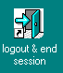Close Exceed. (Click on the STOP icon in the Exceed tool panel, or right click the Exceed button on the TaskBar and choose close.)

Double click on logout and end session.

